University of Washington

Department of Electrical Engineering

EE 478 Final Project:

Hand Gesture Controlled Helicopter

Produced by CheeKai Tan, Chen Yao, Xuanlin Zhu

June 2015

Table of Contents:

1. General System Description 3

1.1 General Description 3

1.2 Functional Specifications 4

1.2.1 Input 4

1.2.2 Output 5

1.2.3 I/O 6

1.3 OLED User Interface 7

2. User Manual 10

2.1 Installing the Flight Battery & Pairing Bluetooth 10

2.2 Control Tests 10

2.3 Understanding the Primary Flight Controls 11

2.4 Flying the helicopter 11

2.4.1 Takeoff 12

2.4.2 Hovering 12

2.4.3 Low Voltage Cutoff (LVC) 12

3. System Hardware Description 13

3.1 Overall System 13

3.2 Board Layout 16

4. System Software Description 23

# General System Description

## General Description

This project is to replace the normal transmitter of a model helicopter with a hand gesture controller. In addition, the helicopter also has the capability to capture data such as distance, temperature and luminance, which will be sent back to the hand gesture controller and displayed on OLED screen. The helicopter control module and hand gesture controller module consist of two separate microcontrollers and communicate via Bluetooth. Figure 1 is an illustration of the overall system of the project.

As a result, all goals have been met. This means a big success has been achieved on the way to change human’s interaction with machine. It also follows today’s trend that this controller is a wearable device. This project is only the start of our human-machine interaction development.

There is still a long way for human-machine interaction and augmented reality.

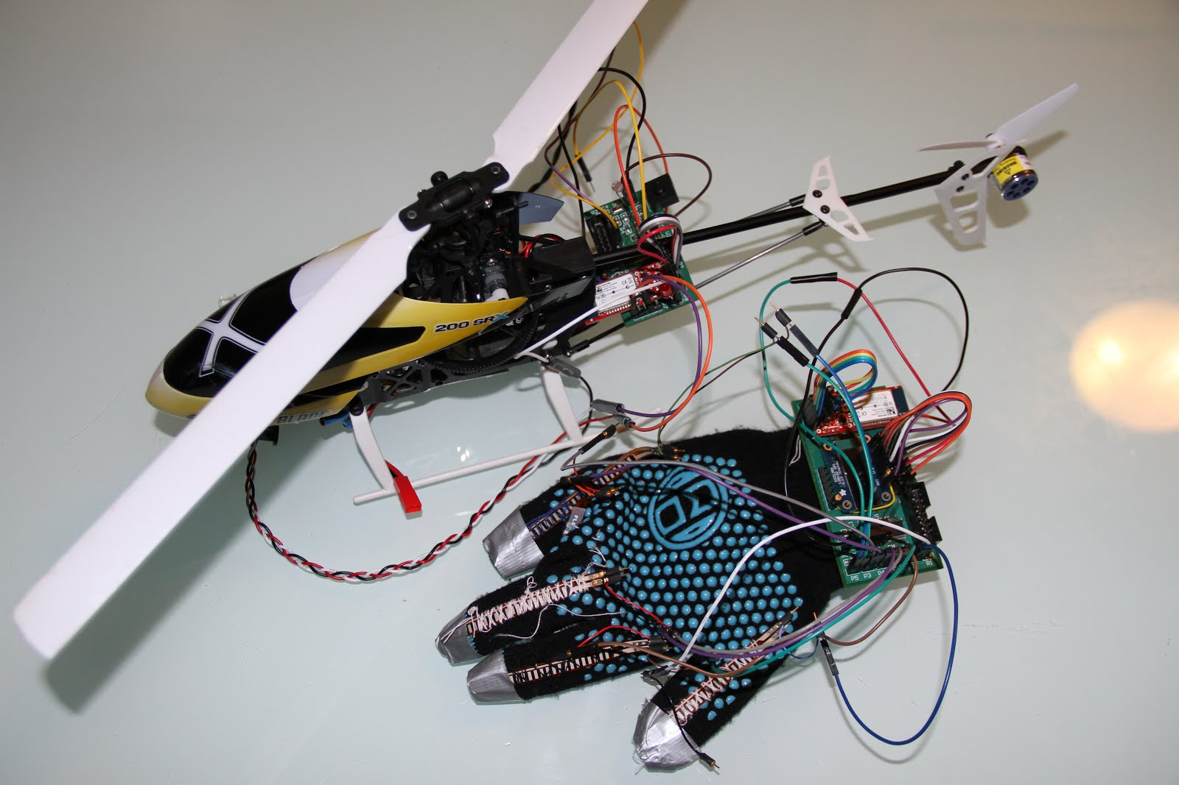

Figure 1. Hand Gesture Controlled Helicopter

## Functional Specifications

### Input

Five flex sensors as user inputs to determine the triggers for the output channels

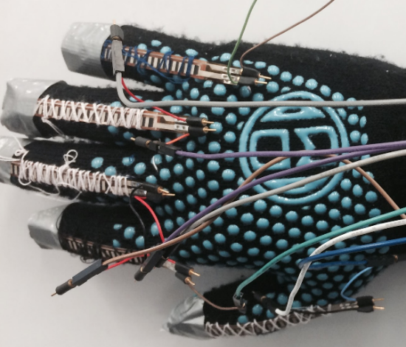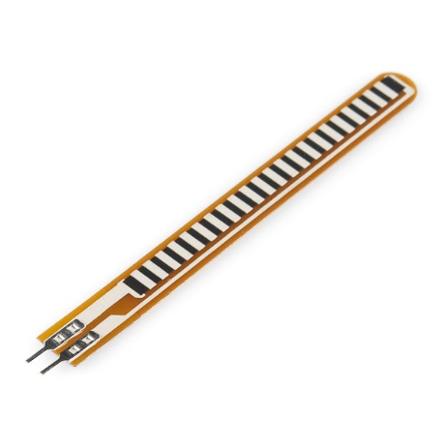

Figure 2. Flex Sensors

Temperature sensor: reads current temperature, with digital SPI output

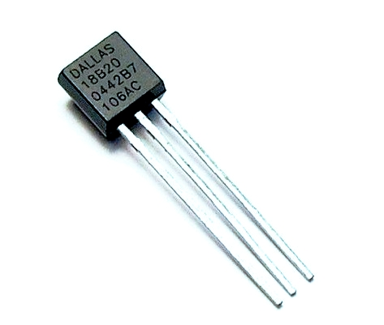

Figure 3. Temperature Sensor

Distance sensor: senses current distance, gives analog output

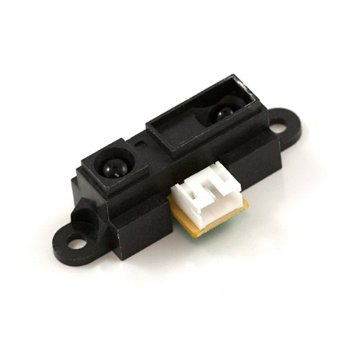

Figure 4. Distance Sensor

Photo resistor: exhibits photoconductivity, gives analog output

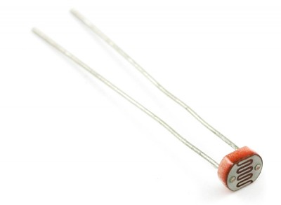

Figure 5. Distance Sensor

### Output

OLED screen: 128X32 resolution, up to 2 lines each with 16 letters.

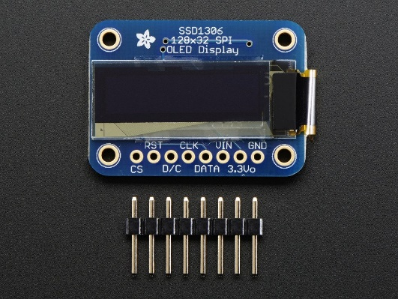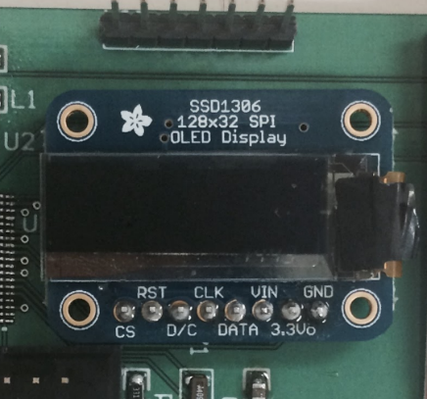

Figure 6. OLED

LED bulb:

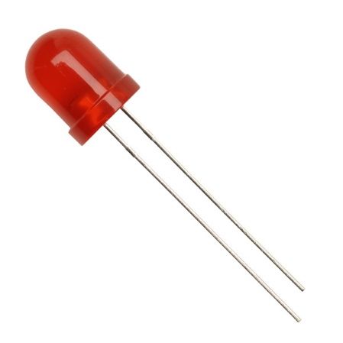

Figure 7. LED bulb

### I/O

Bluetooth: communication device between two modules, with a maximum distance of 18 meters.

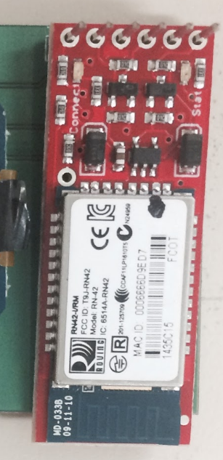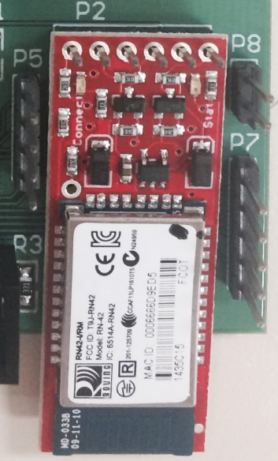

Figure 8. Bluetooth

## OLED User Interface

The temperature data sent from temperature sensor will be displayed on top left side of OLED screen.

The direction of aileron will be displayed on top right side of OLED screen as L (left) or R(right).

The direction of elevator will be displayed on right bottom side of OLED screen as R (forward) or B (backward).

The state of helicopter will be displayed on left bottom side of OLED screen. There are four states for helicopter:

1. IDLE: The helicopter is on the ground. (Figure 9)
2. TAKING OFF: First time curling the little finger while in IDLE state. (Figure 10)
3. SLOW UP: Curling the little finger after taking off. (Figure 11)
4. SLOW DOWN: Flatting the little finger while in air. (Figure 12)

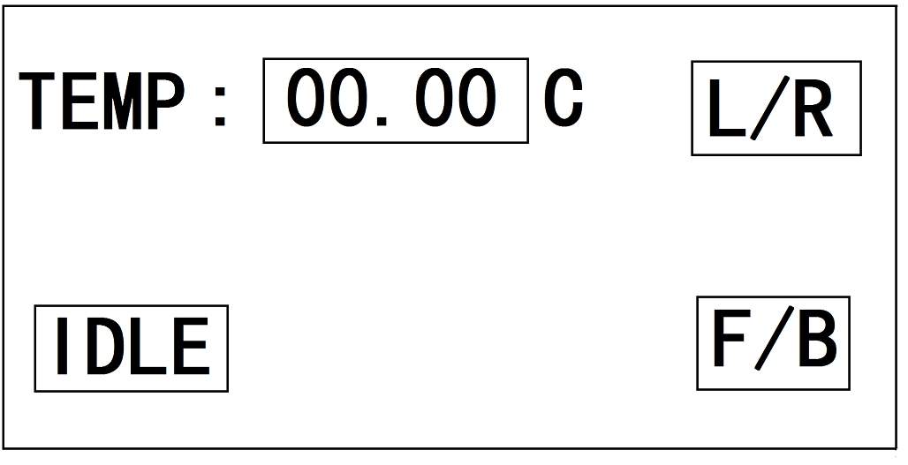

Figure 9. OLED Display when Idle

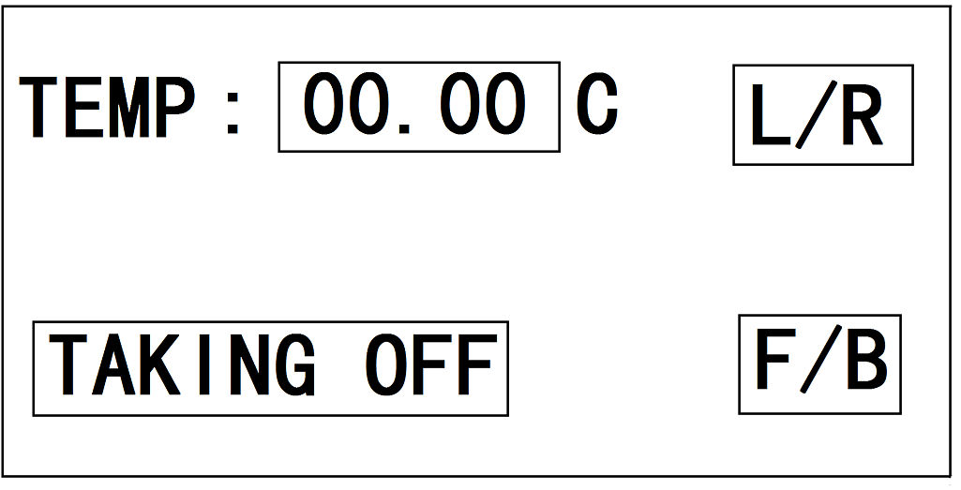

Figure 10. OLED Display when Taking Off

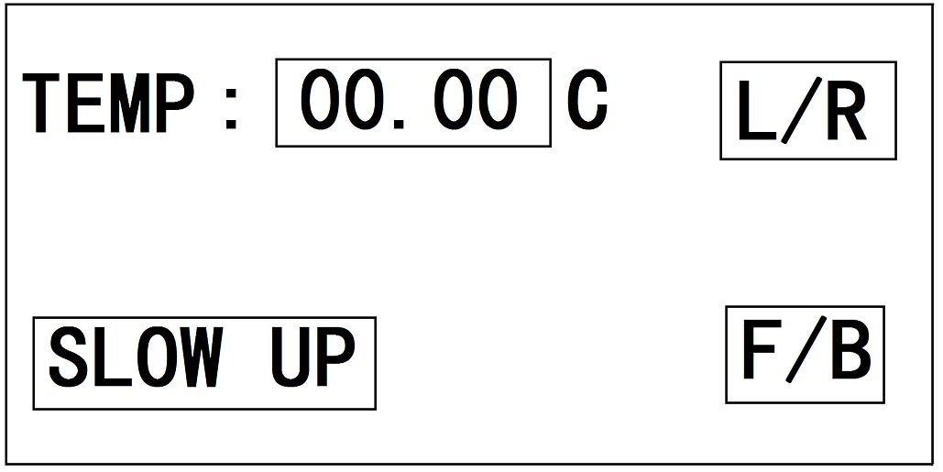

Figure 11. OLED Display at Slow Up mode

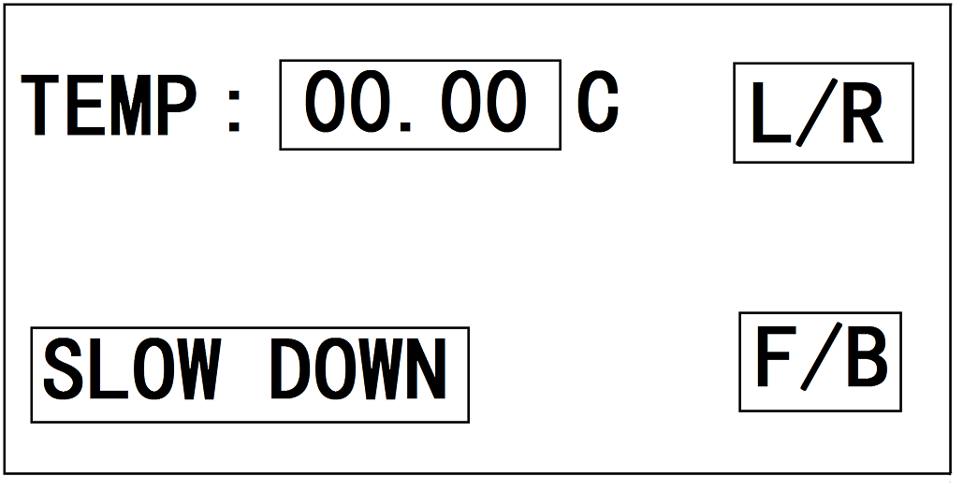

Figure 12. OLED Display at Slow Down Mode

If there is any object within 10 cm of the detecting range of distance sensor, the OLED screen will show “WARNING!!” as in Figure 13.

Figure 13. OLED Display when Warning

# User Manual

## Installing the Flight Battery & Pairing Bluetooth

1. Flat all fingers.

2. Turn on switch on helicopter board.

3. Turn on switch on hand gesture controller board. The LED on Bluetooth will be solid green from flashing red.

4. Attach the hook material to the helicopter frame and the loop material to the flight battery. 5. Install the flight battery on the helicopter frame. Secure the flight battery with the hook and loop strap.

5. Connect the battery connector to the ESC.

6. Place the helicopter on a flat surface and leave it still until the ESC beeps twice and the blue LED glows solid, indicating initialization is complete.

## Control Tests

Test the controls prior to the first flight to ensure the servos, linkages and parts operate correctly. Ensure the throttle is in the low position when doing the control tests.

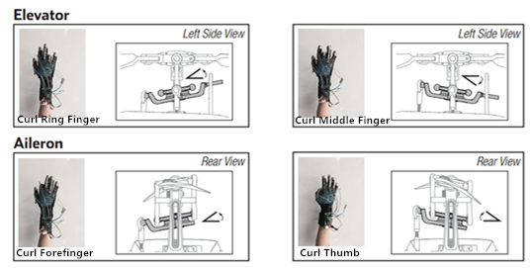

Figure 14. Control Test

## Understanding the Primary Flight Controls

If you are not familiar with the controls of your helicopter, take a few minutes to familiarize yourself with them before attempting your first flight.

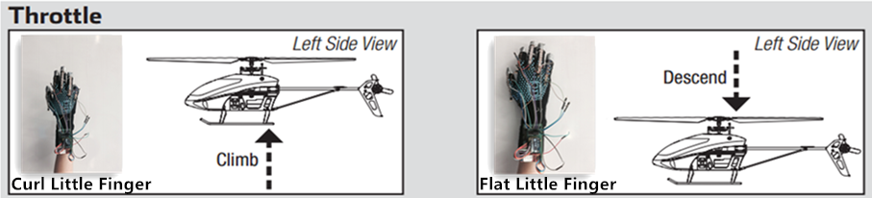

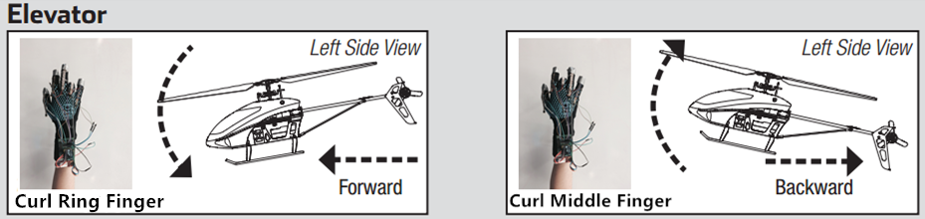

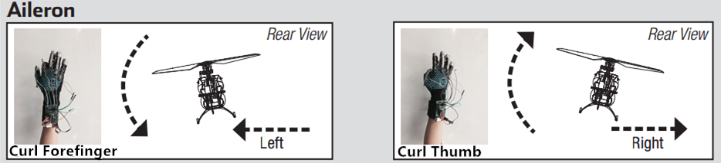

Figure 14. Primary Flight Controls

## Flying the helicopter

Consult your local laws and ordinances before choosing a location to fly your aircraft. We recommend flying your aircraft outside in calm winds (3 MPH or less) or inside a large gymnasium. Always avoid flying near houses, trees, wires and buildings. You should also be careful to avoid flying in areas where there are many people, such as busy parks, schoolyards or soccer fields. It is best to fly from a smooth flat surface as this will allow the model to slide without tipping over. Keep the helicopter approximately 2 ft (600mm) above the ground. Keep the tail pointed toward you during initial flights to keep the control orientation consistent. If you become disoriented, slowly flat little finger to land softly. During initial flights, only attempt hovering the model in one spot and takeoff and landing.

### Takeoff

Place the model onto a flat, level surface free of obstacles and walk back 30 feet (10 meters). Slowly curl little finger until the model is approximately 2 ft. (600mm) off the ground and check that the model flies as desired. Typical flight time for the included battery is approximately 10 minutes.

### Hovering

Making small corrections, try to hold the helicopter in one spot. If flying in calm winds, the model should require almost no corrective inputs. After curling the finger and flatting it, the model should level itself. The model may continue to move due to inertia. Curl the finger for the opposite direction to stop the movement. After you become comfortable hovering, you can progress into flying the model to different locations, keeping the tail pointed towards you at all times. You can also ascend and descend by curling the little finger. Once you're comfortable with these maneuvers, you can attempt flying with the tail in different orientations. It is important to keep in mind that the flight control inputs will rotate with the helicopter, so always try to picture the control inputs relative to the nose of the helicopter. For example, forward will always drop the nose of the helicopter.

### Low Voltage Cutoff (LVC)

LVC decreases the power to the motors when the battery voltage gets low. When the motor power decreases and the red LED on the ESC flashes, land the aircraft immediately and recharge the flight battery. LVC does not prevent the battery from over-discharge during storage.

NOTICE: Repeated flying to LVC will damage the battery. Landing To land, slowly decrease the throttle while in a low-level hover. After landing, disconnect and remove the battery from the aircraft after use to prevent trickle discharge. Fully charge your battery before storing it. During storage, make sure the battery charge does not fall below 3V per cell.

# System Hardware Description

## Overall System

The block diagram below shows the interactions between the system’s main hardware components. Each rectangle represents a major hardware component. Left half of the diagram represents the hardware components used for the hand gesture, whereas right half of the diagram represents the hardware components for the helicopter.

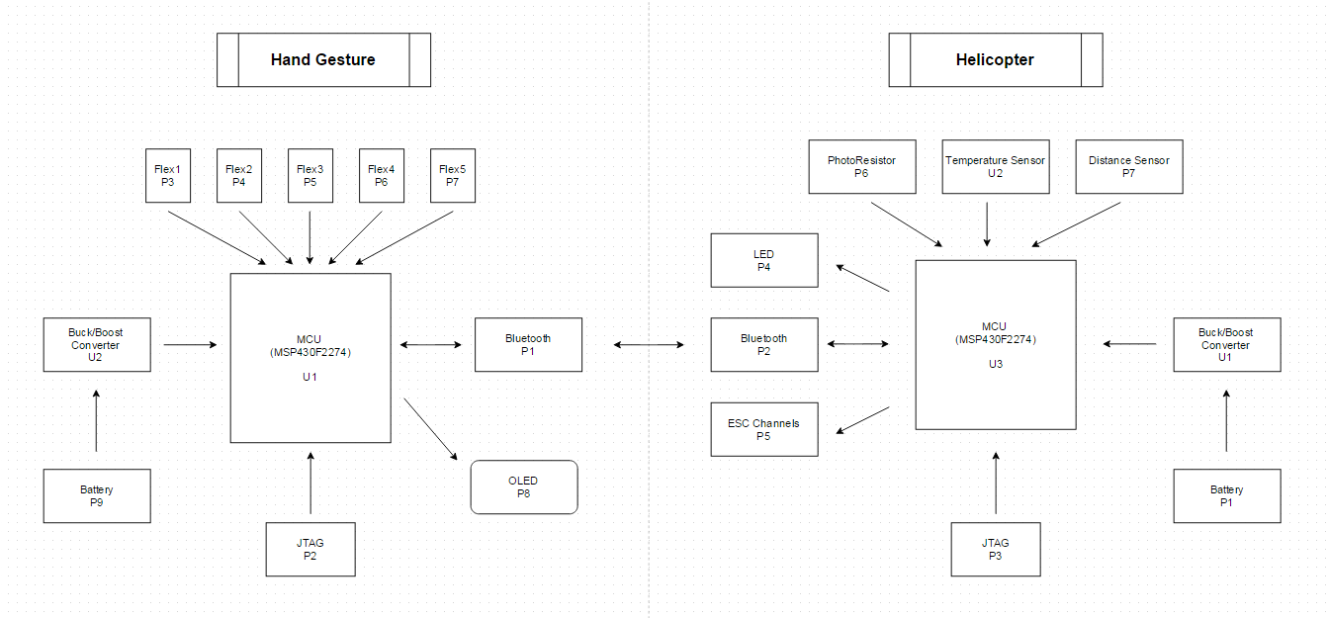

Figure 15. Block Diagram of Overall System

General purpose of each component and how it interacts with the other components is shown in the tables below:

Table 1. Description of Hardware Components (Hand Gesture)

|  |  |  |
| --- | --- | --- |
| Hardware Component | Description | Main Interactions |
| MCU (Microcontroller) | The MCU controls the system, including other hardware components of the system. The MCU implements the software instructions and handles all events that occur. | The MCU takes the voltage from the buck boost converter, read the inputs from the flex sensors. It then displays the information on the OLED and send the trigger status to the MCU on the helicopter using bluetooth. |
| JTAG | The JTAG is a header that allows for debugging and programming the MCU. | The JTAG sends the data to the MCU. |
| Buck/Boost Converter | The buck/boost converter is a device that regulate a constant voltage output of 3.3V, which is the standard voltage for most of the hardware components in the system. | The buck/boost convert takes the voltage from the battery and output a constant voltage to the MCU. |
| Bluetooth | The bluetooth module allows the two MCU to communicate wirelessly for up to 18m of range. | The bluetooth communicates with the other bluetooth on the helicopter. It sends data to that bluetooth, as well as receives data from it. |
| Flex1/2/3/4/5 | The flex sensors allows the status of the finger to be read (i.e. curliness of the fingers). | The flex sensors send the finger status to the MCU. |
| OLED | The OLED allows the user to read the current status of the system (i.e. temperature, helicopter state, finger triggered). | The OLED gets the data from the MCU and displays them. |

Table 2. Description of Hardware Components (Helicopter)

|  |  |  |
| --- | --- | --- |
| Hardware Component | Description | Main Interactions |
| MCU (Microcontroller) | The MCU controls the system, including other hardware components of the system. The MCU implements the software instructions and handles all events that occur. | The MCU takes the voltage from the buck boost converter, read the inputs from the photo resistor, temperature sensor, and distance sensor. It then turn on/off the LED and generate several PWM signals to control the helicopter. Furthermore, it sends the helicopter state and temperature to the MCU on the helicopter using Bluetooth. |
| JTAG | The JTAG is a header that allows for debugging and programming the MCU. | The JTAG sends the data to the MCU. |
| Buck/Boost Converter | The buck/boost converter is a device that regulate a constant voltage output of 3.3V, which is the standard voltage for most of the hardware components in the system. | The buck/boost convert takes the voltage from the battery and output a constant voltage to the MCU. |
| Bluetooth | The Bluetooth module allows the two MCU to communicate wirelessly for up to 18m of range. | The Bluetooth communicates with the other Bluetooth on the hand gesture unit. It sends data to that Bluetooth, as well as receives data from it. |
| Photo Resistor | The photo resistor provides the reading of the environmental brightness. Its resistance is inversely proportional to the brightness. In the other words, the brighter the environment, the lesser the resistance will be. | The photoresist or sends the resistance value, which represents the brightness of the room, to the MCU. |
| Temperature Sensor | The temperature sensor provides the reading of the room temperature. | The temperature sensor sends the temperature value to the MCU. |
| Distance Sensor | The distance sensor provides the distance between the sensor and the object in front of the sensor. If there is no object, or if the object is too far from the sensor (more than 80cm), the reading will be zero. | The distance sensor sends the distance value to the MCU. |
| LED | The LED will be turn on and lit if the environment is too dark. On the other hand, it will turn off if the environment is bright enough. | The LED gets the signal from the MCU. |
| ESC Channels | The electronic speed control (ESC) channels will produce PWM signals that control the servos and motors on the helicopter. | The ESC channels obtains the PWM signals from the MCU. |

## Board Layout

The hardware components described in the System Hardware Overview in this section. The Board Layout shows the general locations of each major hardware component on the PCB (Printed Circuit Board) layout. The component designations (U1, U2, R1, etc.) correspond to the component labels in the schematics for each major hardware component.

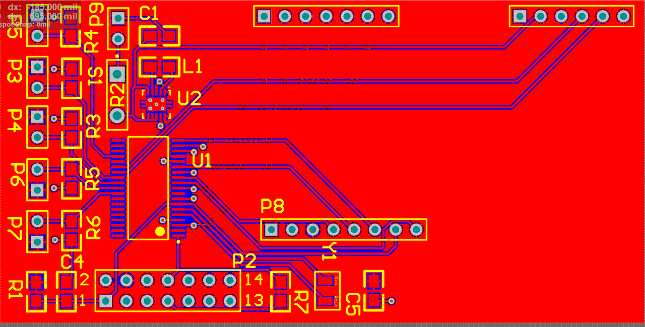

Figure 16. Board Layout without Labels (Hand Gesture)

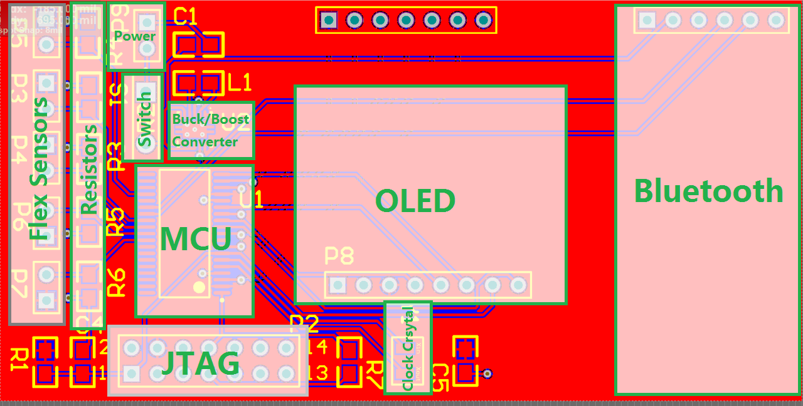

Figure 17. Board Layout with Labels (Hand Gesture)

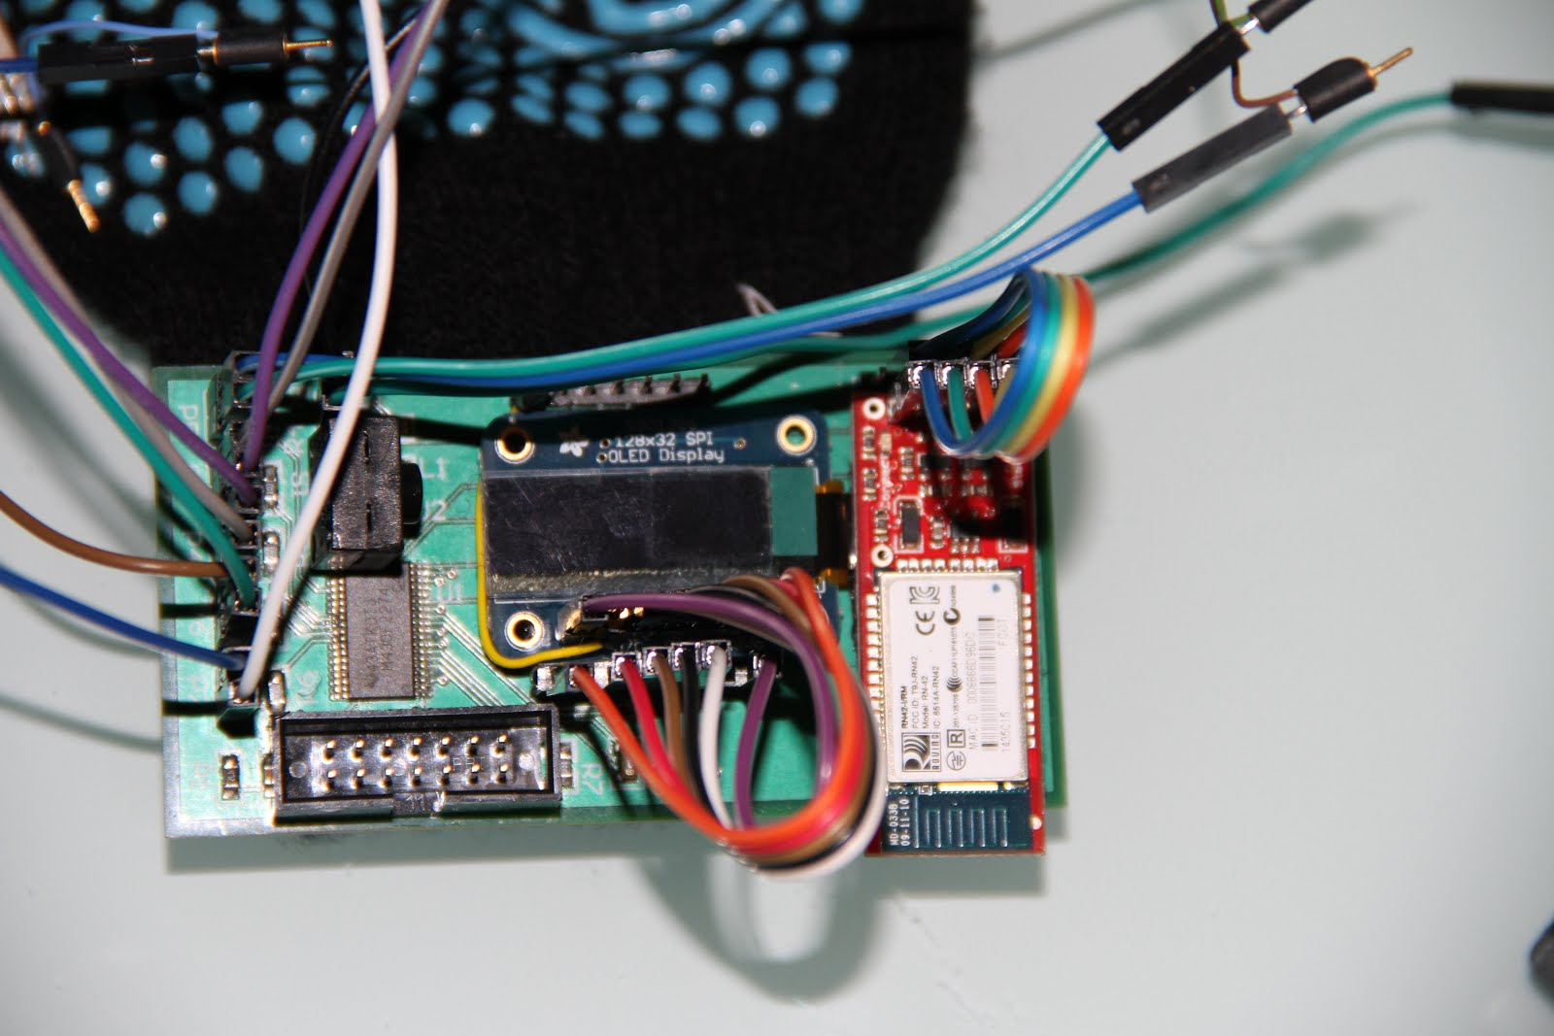

Figure 18. PCB of Hand Gesture with Components

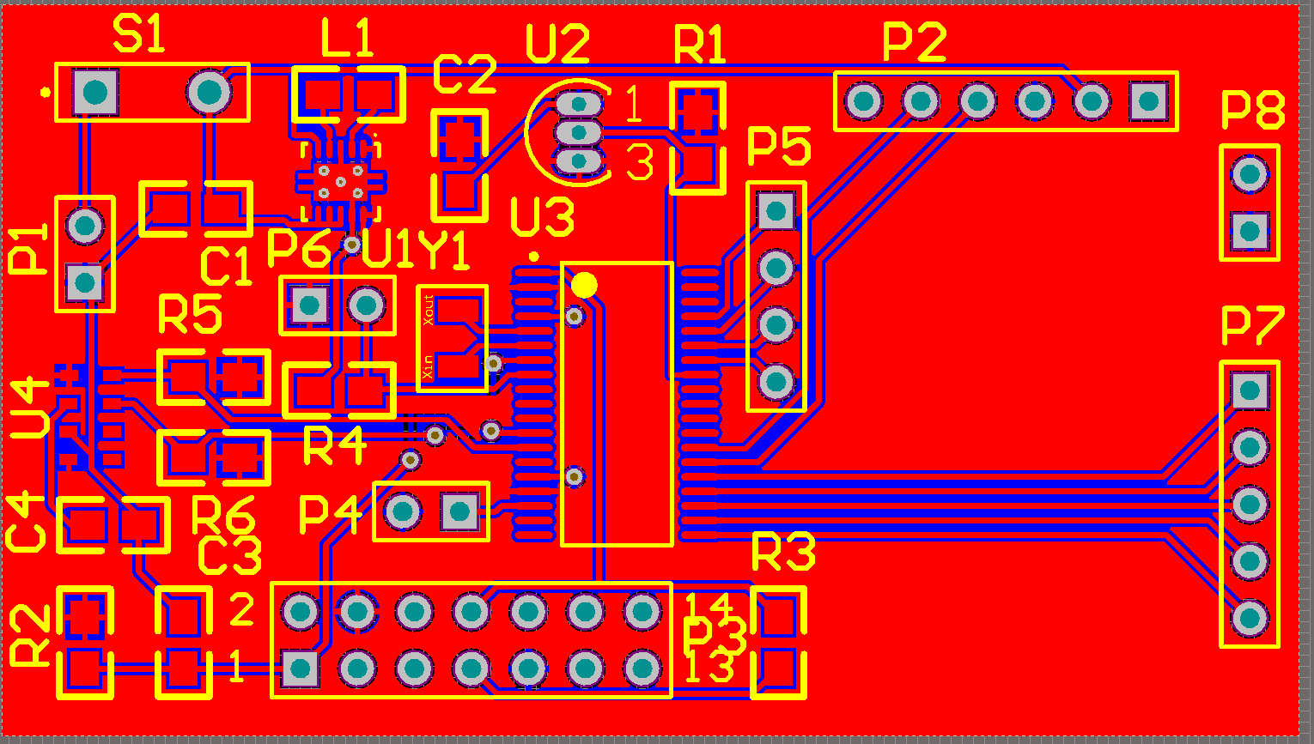

Figure 19. Board Layout without Labels (Helicopter)

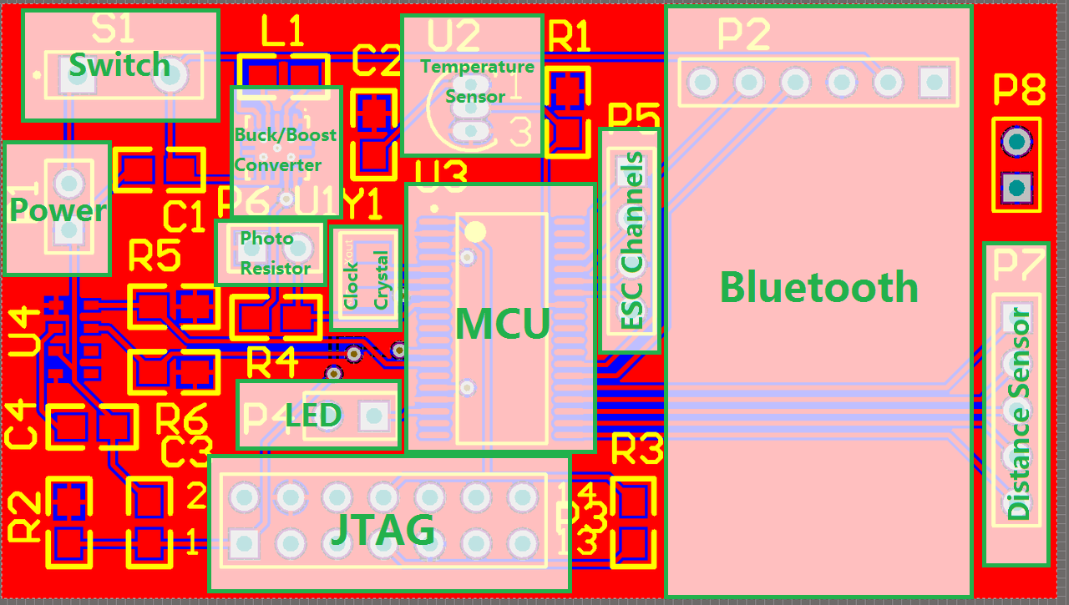

Figure 20. Board Layout with Labels (Helicopter)

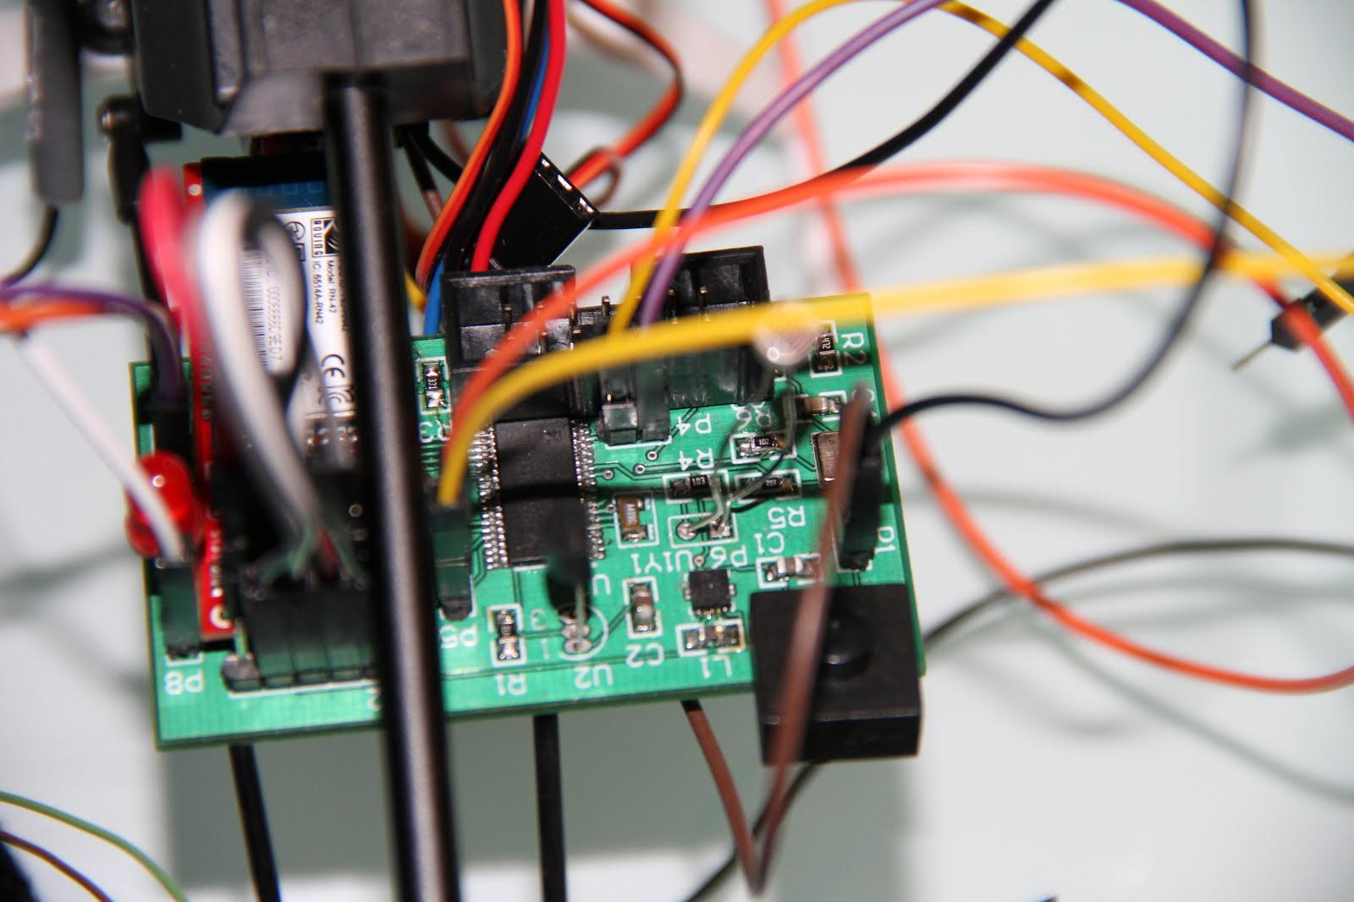

Figure 21. PCB of Helicopter with Components

# System Software Description

The block diagrams below shows the relationships between major components of the overall software in the Hand Gesture Controlled Helicopter system. Each block represents a module in the system, which containing number of relevant functions. The blocks are color coded so that the relationships between files are easily distinguishable.

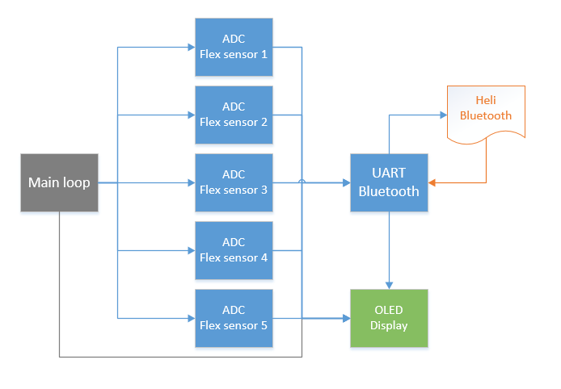

Figure 22. Block Diagram of major modules (Hand Gesture)

The main loop controls the readings of the five flex sensors through analog to digital convertors. After the data are acquired, they will be processed, sent to helicopter via Bluetooth and displayed on the OLED screen. Data that been sent from the helicopter to hand gesture via Bluetooth will also be displayed on the screen.

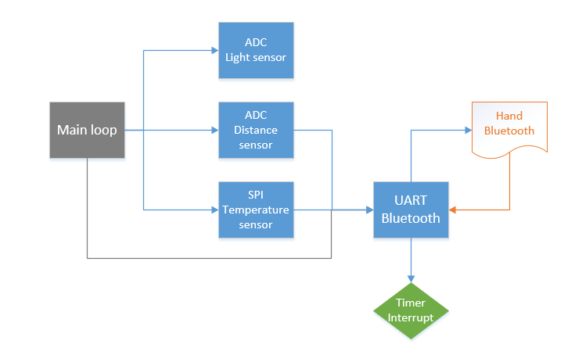

Figure 23. Block Diagram of major modules (Helicopter)

The main loop controls the reading of data from light sensor (photo resistor), distance sensor and temperature sensor via proper channels. These data will be processed and sent to hand gesture via Bluetooth. The data that been sent from hand gesture to the helicopter via Bluetooth will be used by the timer interrupt to determine the output PWM for the electronic speed controller. Within the output PWM, throttle is the most important output. It is a state machine controlled by throttle trigger, which is determined by the data sent from the hand gesture. The following diagram shows the states of throttle and the conditions to switch states.

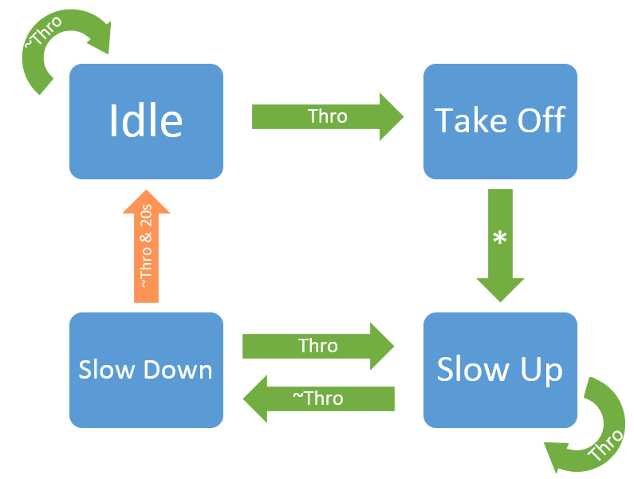

Figure 24. State Diagram of Throttle (Helicopter)